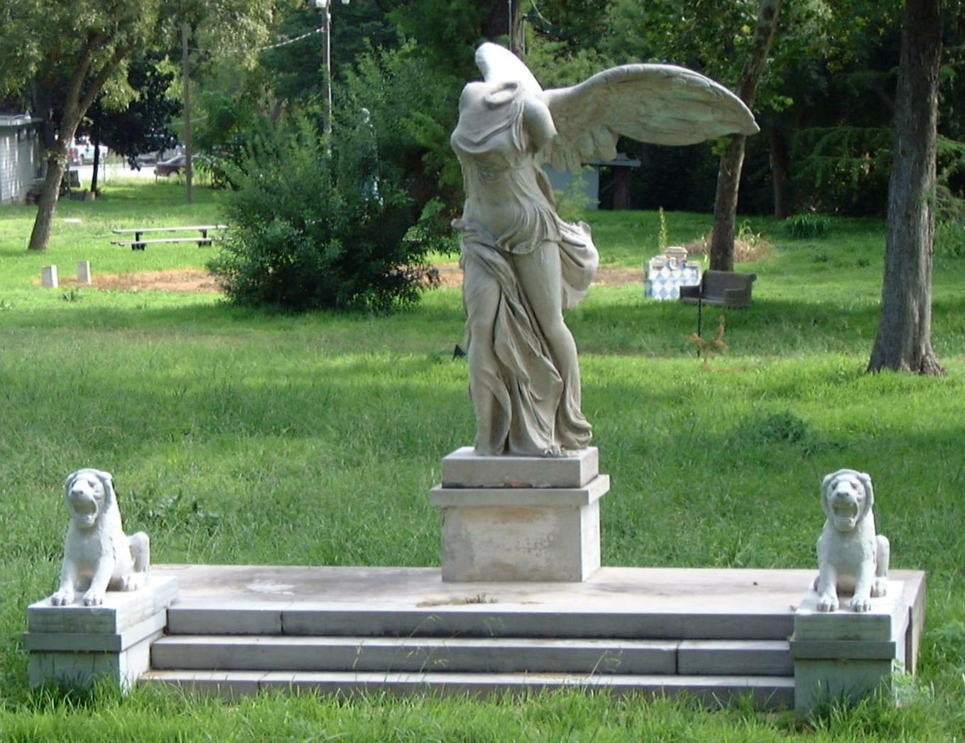
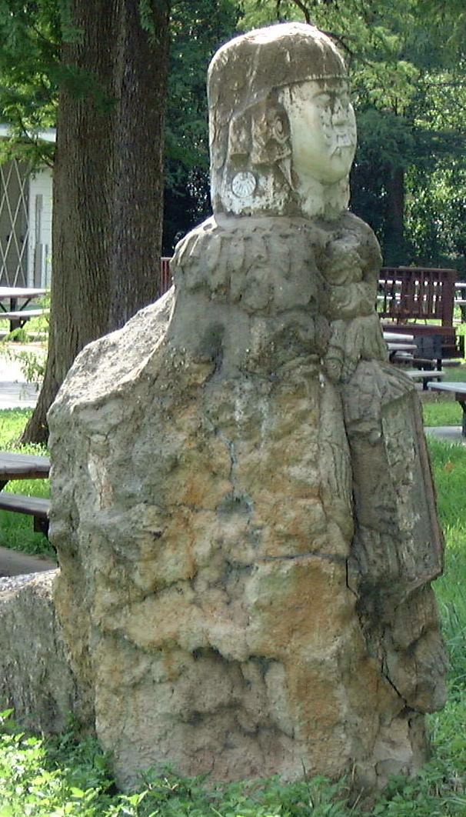
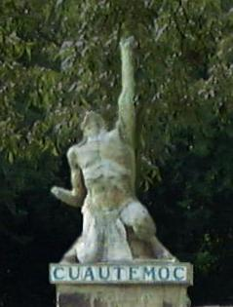
Replica of Winged Victory of Samothrace by unknown artist with lions on either side. Originally located at Quinta Urrutia on Broadway.

Left: Pre-Columbian Indian Idol done by Sanchez Lopez.
Right: Cuautemoc, last Aztec Emperor, also done by Sanchez Lopez.
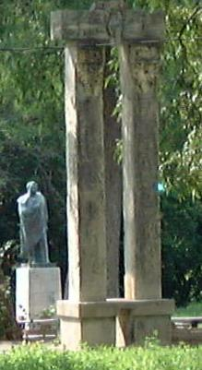
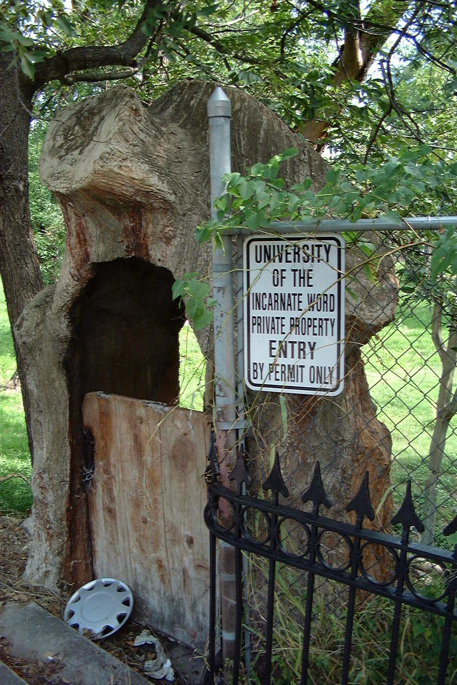
Both pictures on the right are examples of Dionicio Rodriguez’s work. Top Left: columns that are part of a fountain and bronze of Dr. Urrutia in background. Bottom Left: Ave Maria grotto statue done by unknown artist.

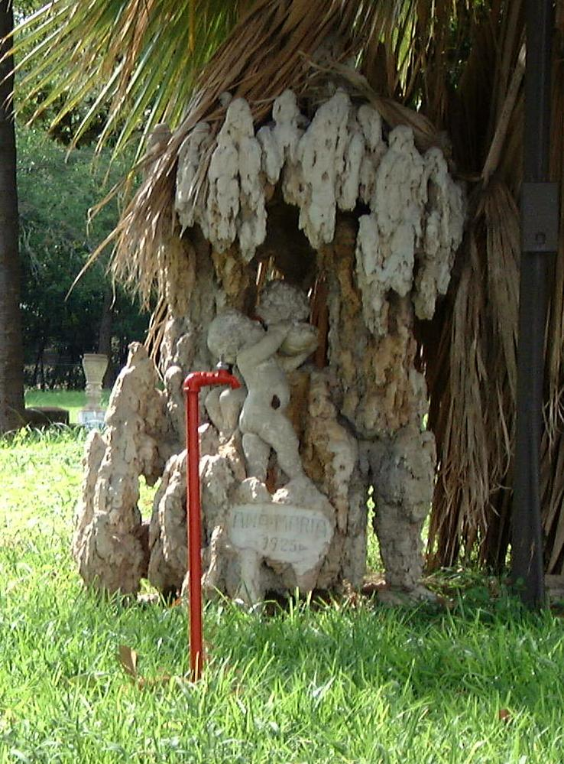
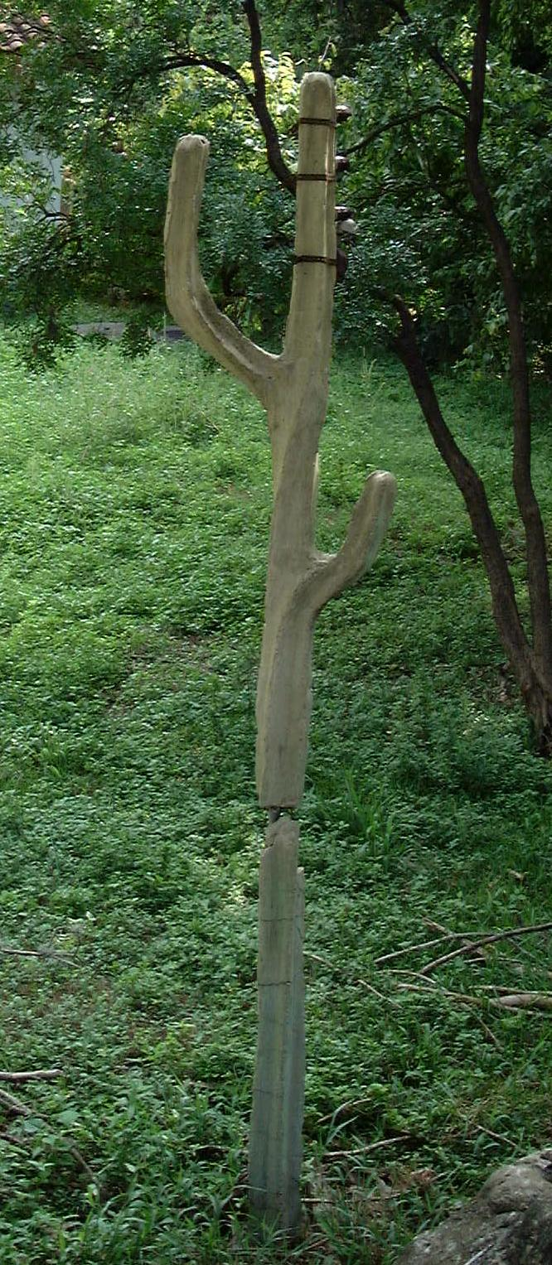
The plaque below speaks most pertinent information, but this in the front view of the gate that moved to the museum.

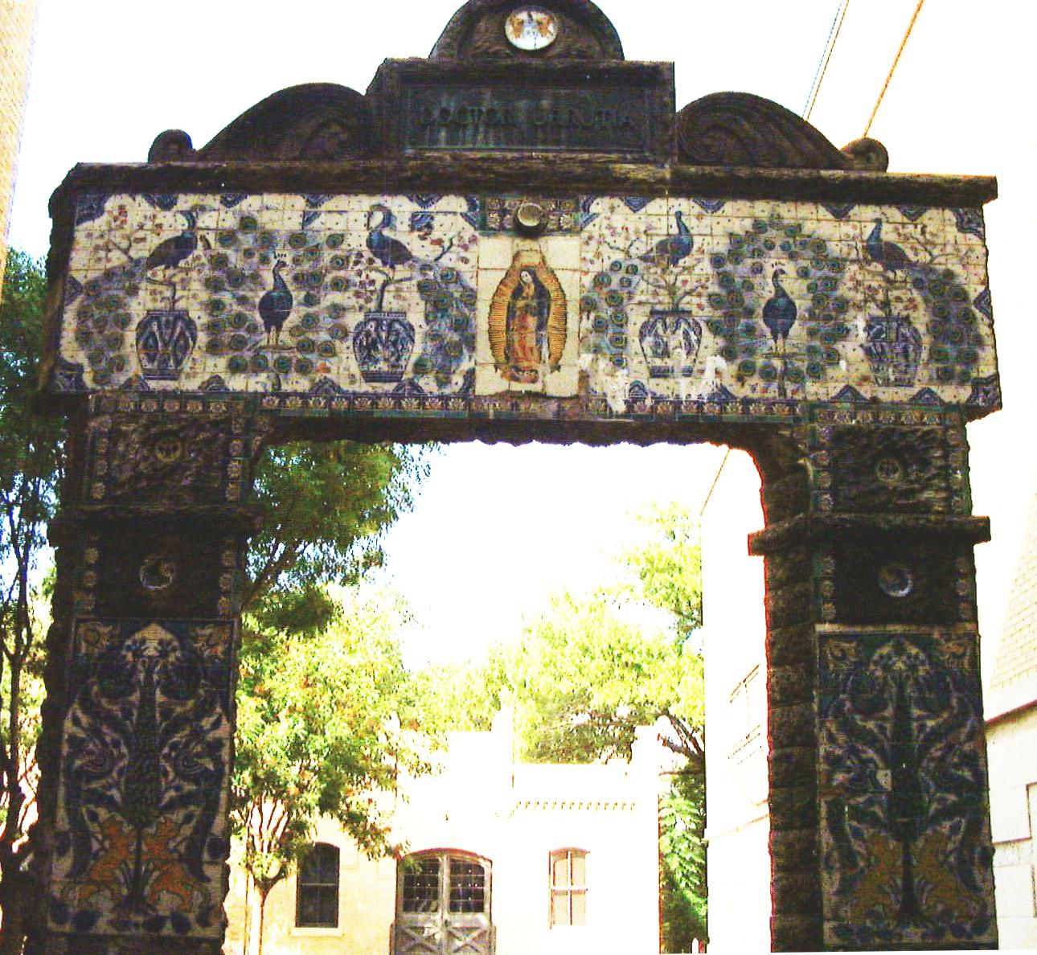
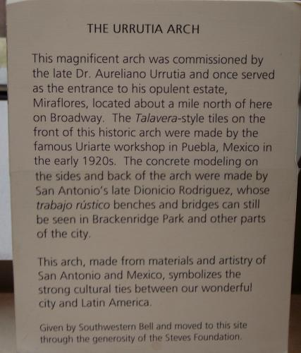
Top: the backside of the gate that was moved to the San Antonio Museum of Art
Bottom: The backside of the gate still located on Hildebrand
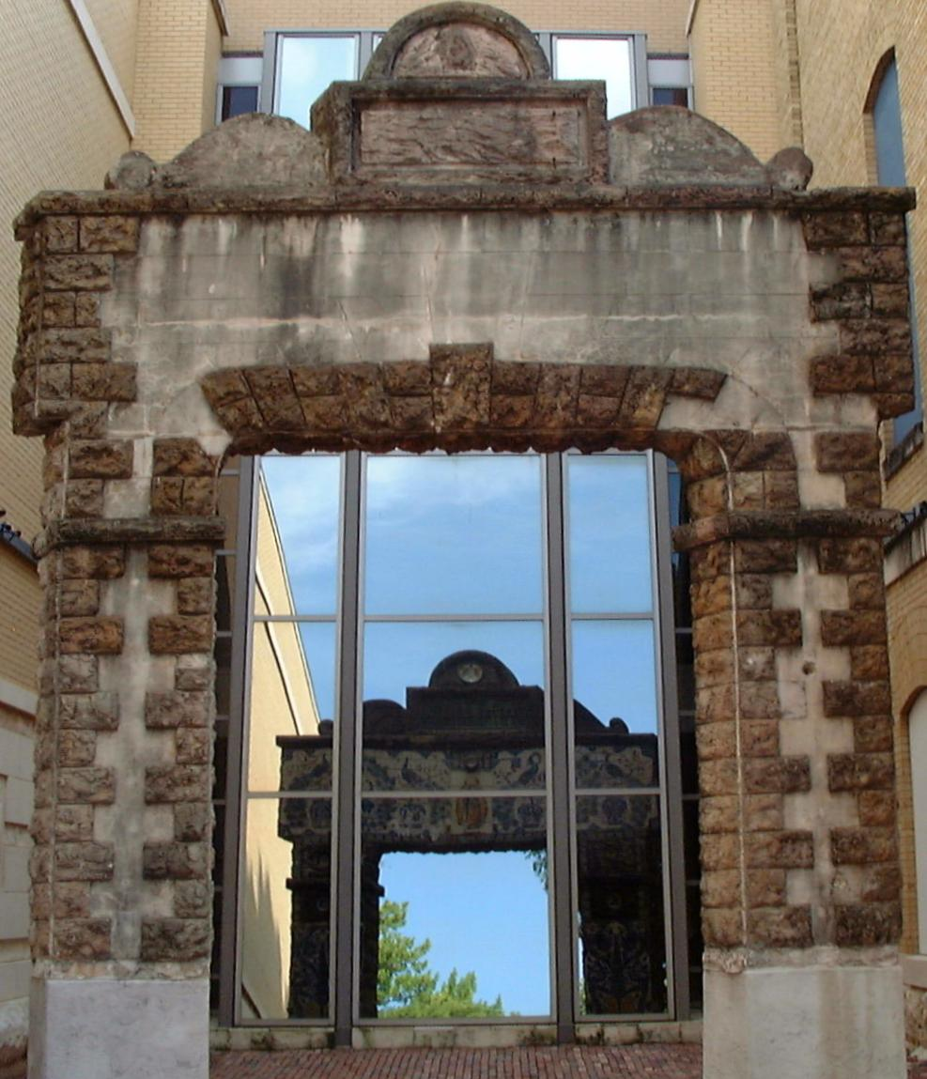
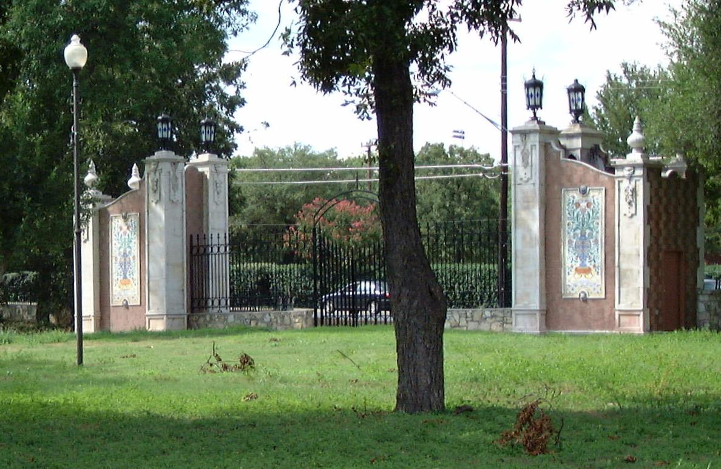

This is the gate that is still on Hildebrand and commemmorates the 400th anniversary of Mexico City’s founding. It also says when the park was founded, a civil engineer’s name, and Dr. Urrutia’s name.
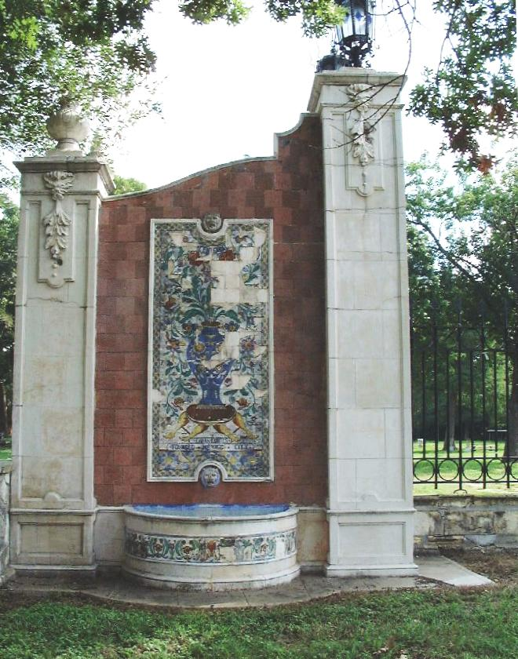
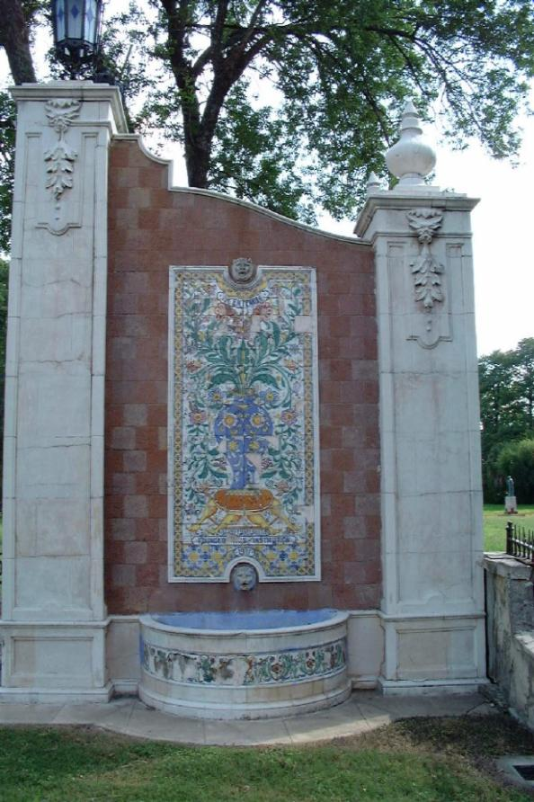

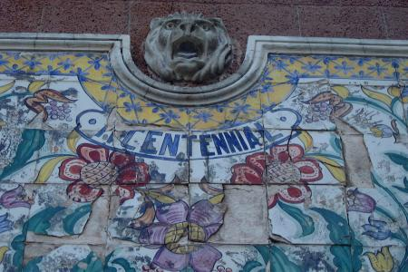
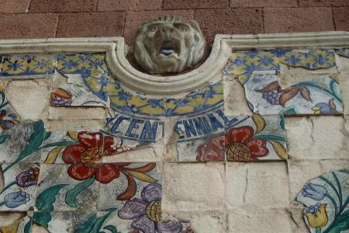

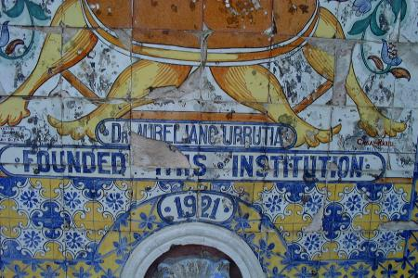
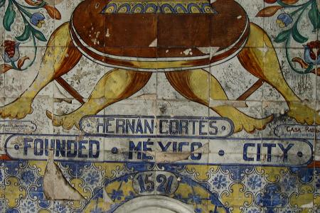

This is the bench that is inlaid from tiles from the home of Hernan Cortez dating back to the 1500’s.
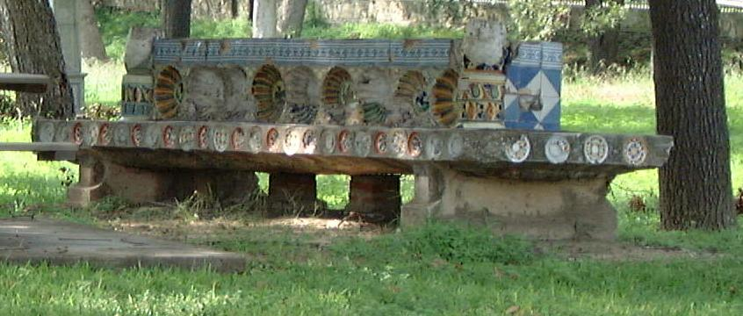
This is the bench that Dionicio Rodriguez made for this park. It is made of concrete over a metal frame.
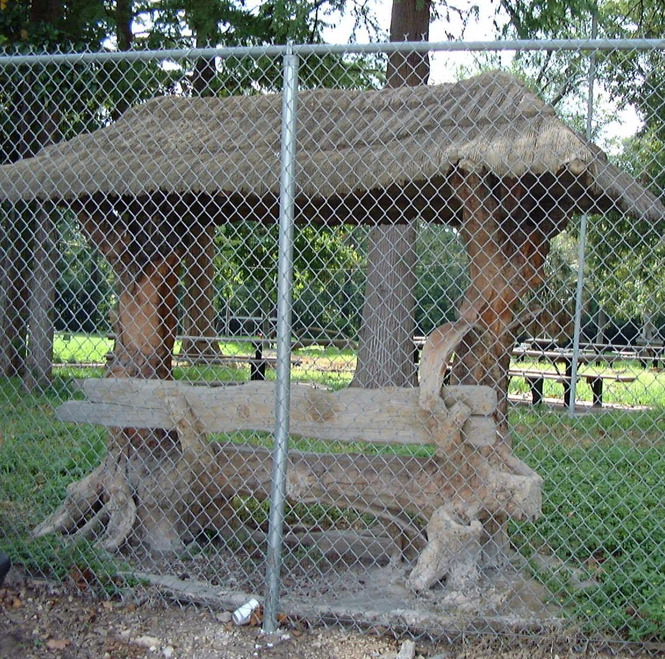

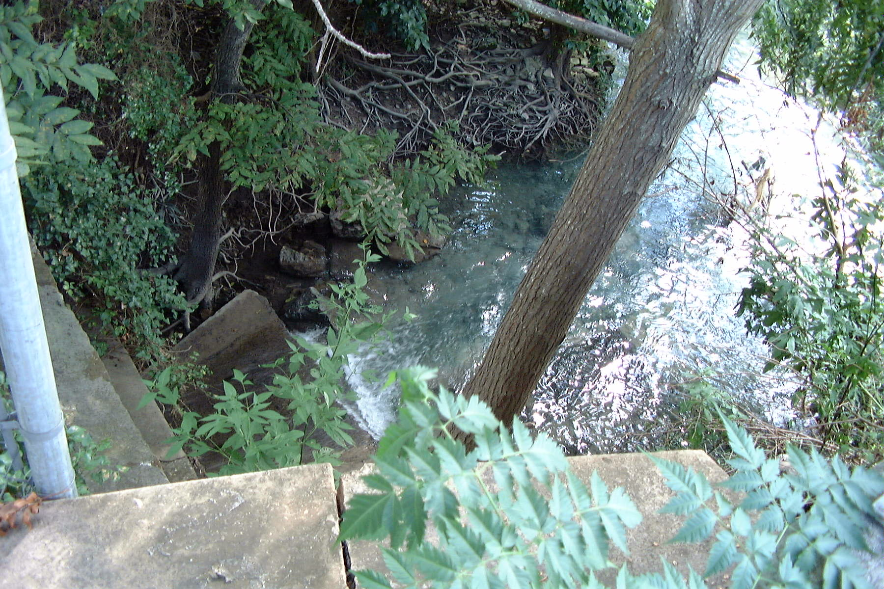
These are both pictures of the San Antonio River water just below the headwaters that are in Brackenridge Park.
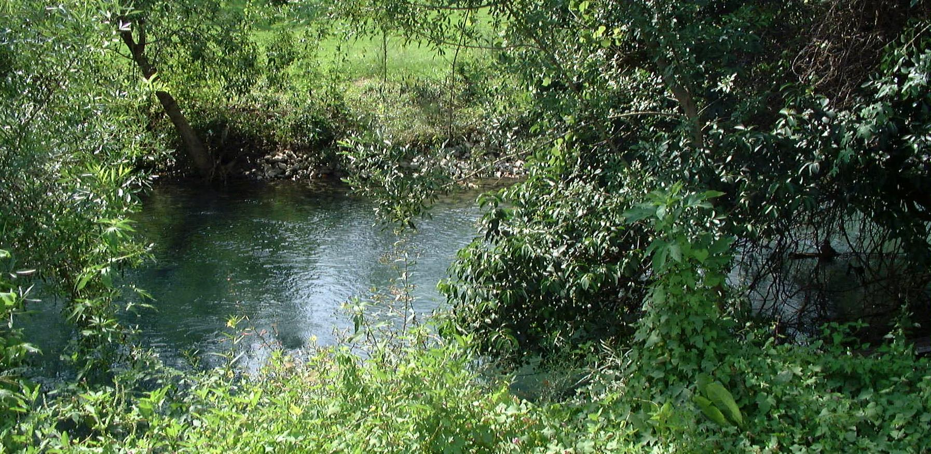

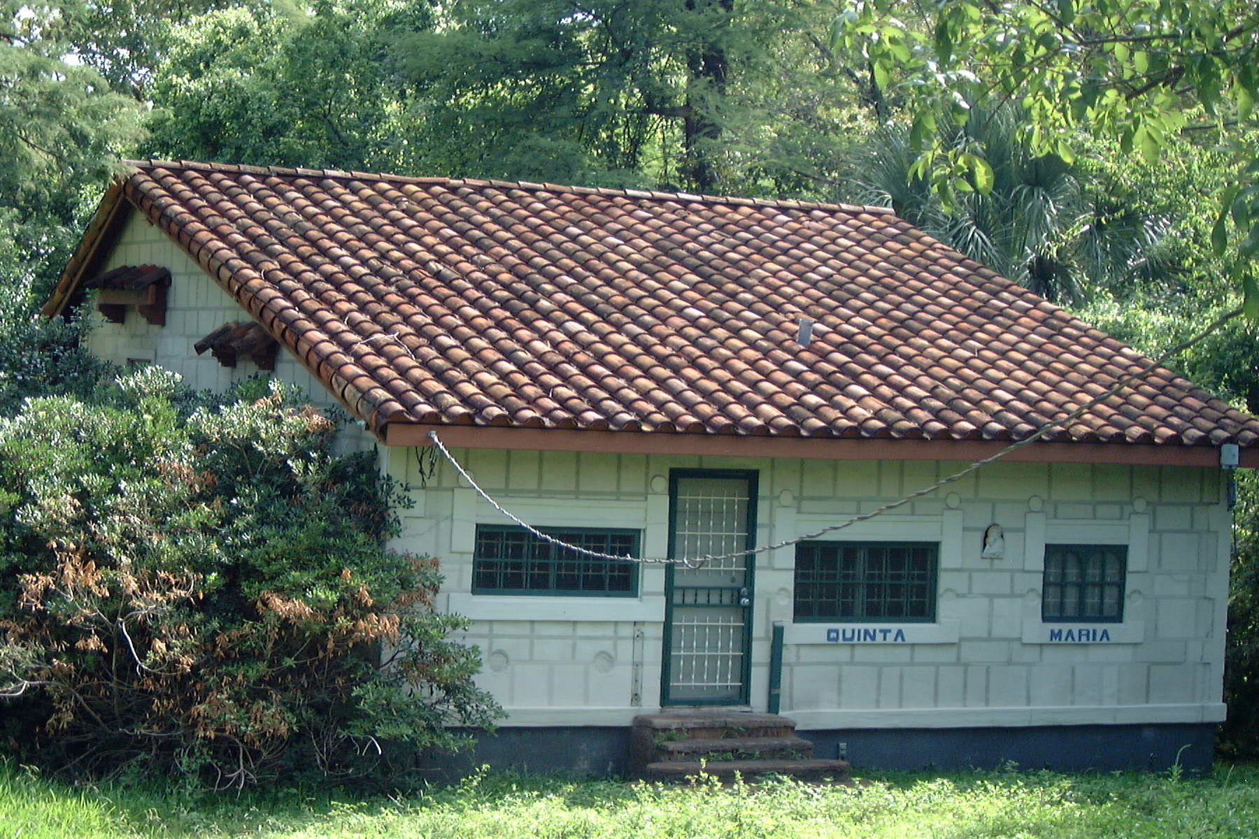
Above: This is the building original to the property that SWB renovated.
Below: The picnic tables and barbecue pavilion that the Pioneers added.

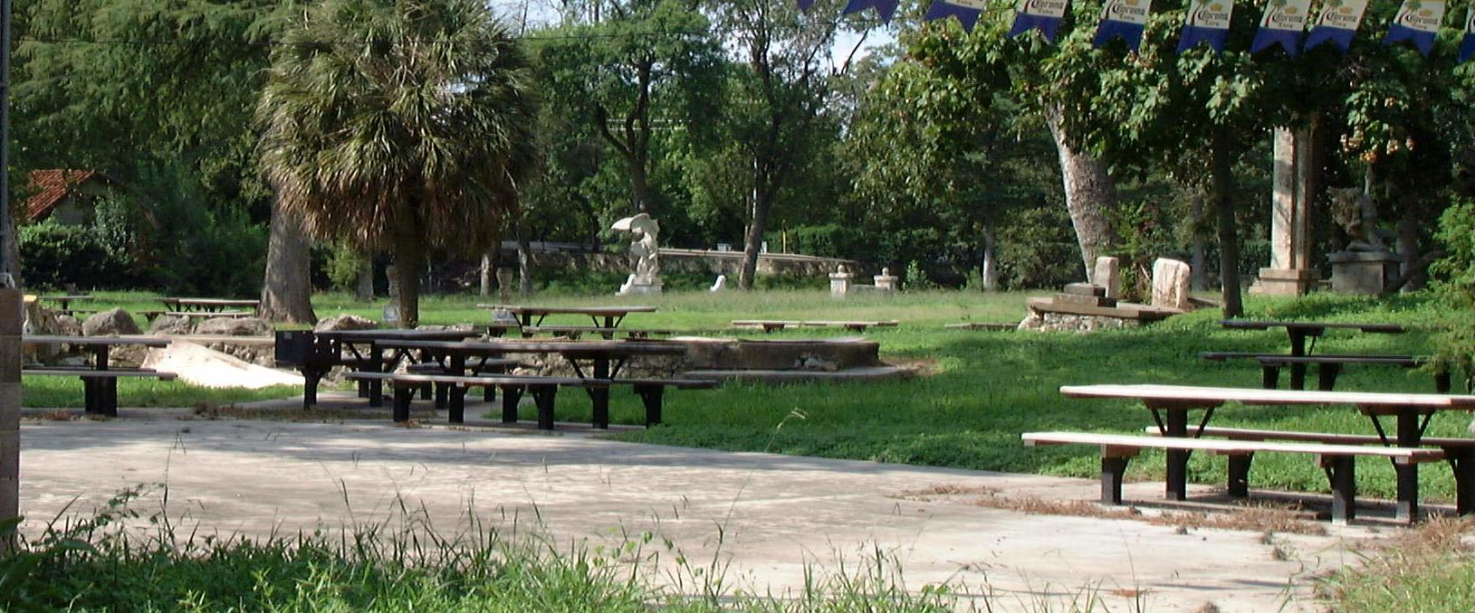

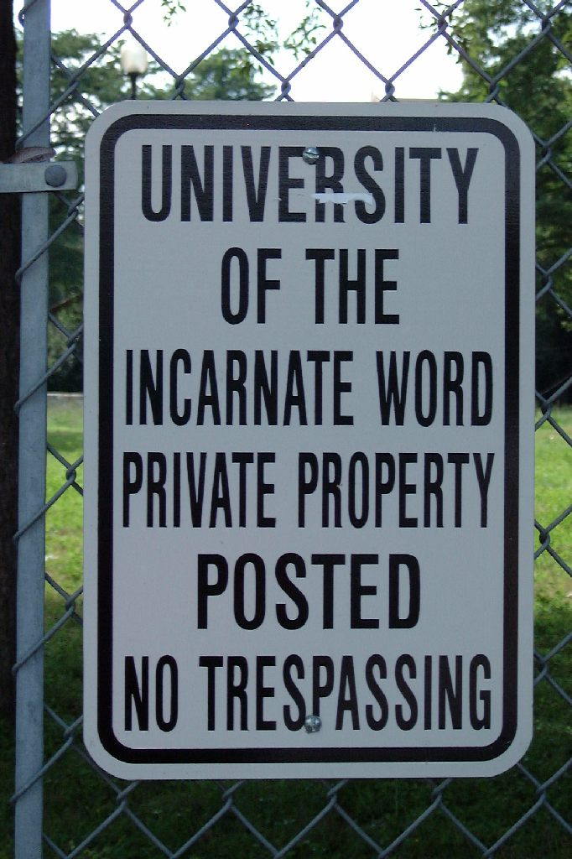
Bummer.

